TITLE (limit 30 words)
Sentence formatting (i.e., avoiding all caps) (Arial 12 pt.)

First Name Last Name (presenting author)^{a,}*, First Name Last Name^{a,b}, First Name Last Name)^{b} … (Arial 11 pt.)

ª Institution, City, Country (Italics, Arial 10 pt.)
^{b} Institution, City, Country
*e-mail of presenting author: xxx@yyy.zz

Abstract

A4 format, maximum 1 page
Top margin 1.5 cm. Left, right and lower margin 2.5 cm
Multiple 1.15 spacing
Main body of the abstract: justified
Arial 11 pt.
Figures, tables, acknowledgements and references are optional

Please do not change the format of this template.
Save the abstract in Word format (.docx or .doc).

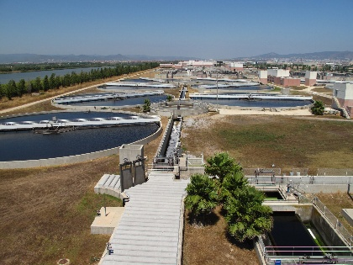
Figure 1. Figure Title (Arial, 9 pt.)

Table 1. Table Title (Arial, 9 pt.)
Heading 1 | Heading 2 | Heading 3
Fila 1 | 1 | 1
Fila 2 | 1 | 1

Acknowledgements
(Arial 8 pt.)

References (ACS format, Arial 8 pt.)
(1) Surname, A.; Surname, B. Journal Title Year, Volume, page.

